Subsea Dropped object Risk Assessment Calculation Software:
Standalone software to be developed based on DNVGL F-107 guidance (attached). Should have ability for licensing (annual). (See Youtube video for information, https://www.youtube.com/watch?v=VJHmWjmmUis
Should have option to
- input values (manually or import from excel tabes)
- Import PDF file and scale it and measure distance within each rings from the PDF drawings
- Generation of report / output (to word). Text, figures, tables and graphs.
General input:
- Water depth (m)
- Density of water (kg.m3)
- Max distance of interest from drop point (m)
- Type of pipeline / riser (Umbilical / Steel pipeline / Flexible pipeline / Pipe-in-pipe-PIP)
- Pipeline details
  - Size (inch)
  - Outer Dia (m) (if PIP, in addition ask for inner pipe OD)
  - Wall Thickness (m) (if PIP, in addition ask for inner pipe wall thickness)
  - Material of construction (if PIP, in addition ask for inner pipe Material)
  - Material Yield Stress N/m2 (if PIP, in addition ask for inner pipe Material)
- Drag Coefficient of the Object (C_{d}) (low / mid or higher value option plus custom value input option)
- Added Mass Coefficient (C_{a}) (low / mid or higher value option plus custom value option)
- Drop Frequency per lift
- Probability of drop over water
- Probability of wind direction (FPSO)

Lift Manifest input (to calculate impact energy)
Required min 50 rows
Should have ability to (a) input manually via software input (b) copy and paste table from excel sheet or (c) import from excel sheet to the software.
The software should sort the object dimension as Largest will be length, 2nd longest will be depth and lowest will be height, if they are not given in the right order
Impact Energy Calculations: (see excel sheet for calculation steps)
(1) Assumption: If Length is greater than 3 times the depth, then the object is considered as Flat/Long shaped, otherwise it is considered as Box/Round Shape.
(2) Weight category as per Table 5-2
(3) Angular Deviation category number (1 to 7) as per Table 5-2(3)
(4) Angular Deviation Degree as per Table 5-2
(5) Volume of object (l * w * h)
(7) Projected area as per Sec 5.3.3
(Note- For any further calculations Angle to be provided in Radians in Excel)
(8) Estimation of Volume of free space available (for water filling)
- Volume of steel (m3) = Mass of object (kg) / Density of steel (7810kg/m3)
-Free volume available for water filling (m3) = Volume of object (6) – Volume of Steel (8)

(Cd) Drag coefficient
(Ca) Added Mass Coefficient
Estimation based on Table 5-3, Selection made in general input on whether to use the lower values / medium values / upper values for Ca and Cd.
(9) Added Mass (ma)
= Water density (input) x Ca x Free volume (8A)
(10b) Subsea Terminal Velocity (estimated as per equation 13)
(10a) For depth less than 50m, Velocity estimated as Vt= √(2gh);
(11 a and b) Subsea Impact Energy (estimated as per equation 16) and the output (in Joules) is converted to kJ
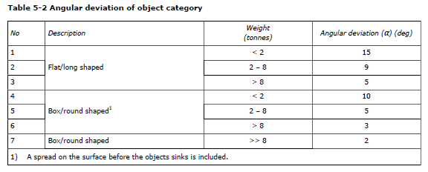
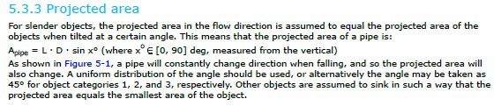
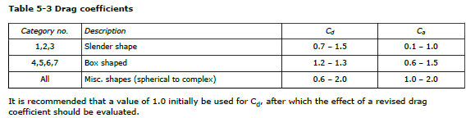
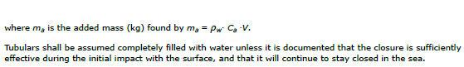

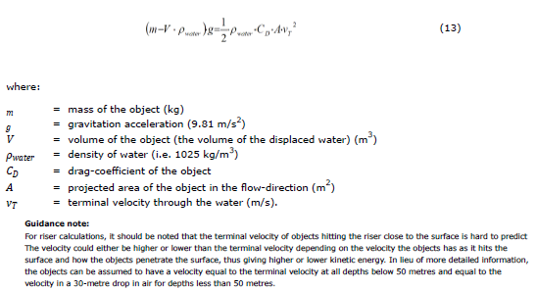
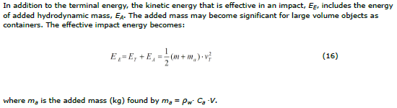
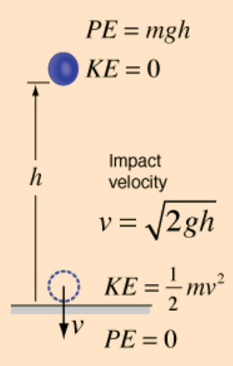

Pipeline layout / distance input:
Depth Rows:
Depth row should automatically increase with 10m step up to the water depth (input). Last row should be the max water depth (input)
Ring Radius Column:
Ring Radius column should automatically increase with 10m steps up to Max distance of interest from drop point (input from user input in the imported PDF drawing)
- The pipeline length within each concentric ring (increasing by 10m radius) to be automatically calculated by bringing in the PDF drawings and scaling it and then drawing concentric ring from the drop point (to be cross marked manually), then calculating the length of pipe within each concentric ring and automatically populating the table.
- This is now manually input in excel (in the table 1 below).
Table 2: Type of Impact expected on the pipeline within each ring (Dropdown list Selection: Perpendicular impact (default) / Angular impact (based on angular deviation of the object) / Fully Shielded)
- Blankout cells which does not have values in the Table 1
- Only cells with value in Table 1 will be open for dropdown box selection.

Table 3: Impact protection available within each ring - value input (KJ)

Impact Resistance Calculation:
Based on the type of pipeline in general input ((Umbilical / Steel pipeline / Flexible pipeline / Pipe-in-pipe-PIP)), the right formula is used to estimate the impact resistance offered by the pipe to create a 5%, 10%, 15% and 20% dent (d/D) on the pipeline.
Note: depending on the pipeline diameter the value in Table 4, 5, 6 will increase or decrease by 25% (see F-107 )
From this impact resistance calculation (and using the right pipeline table the probability of D1, D2, D3 and R0, R1 and R2 is estimated (for further frequency calculation).
For information See Impact resistance Calculation Sheet in Excel file

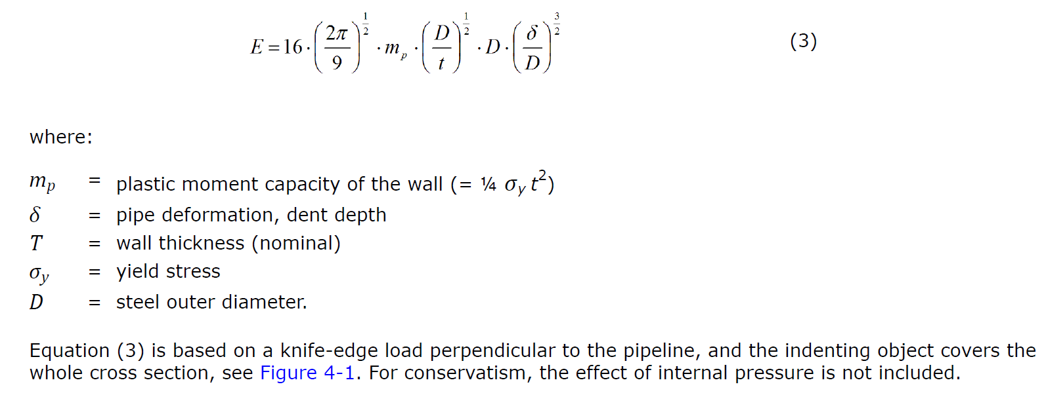
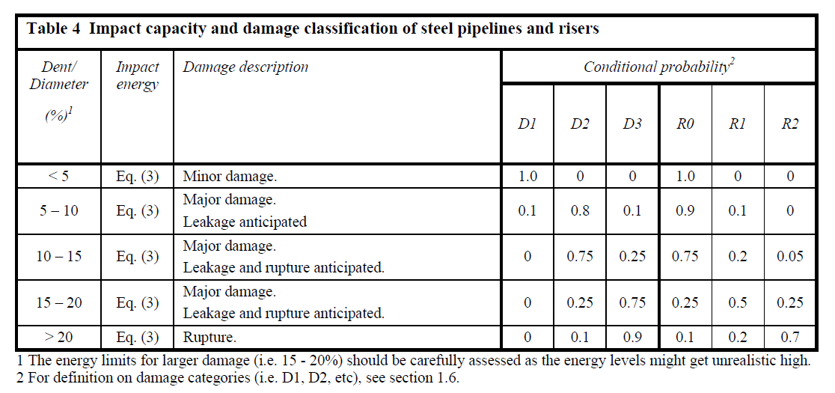

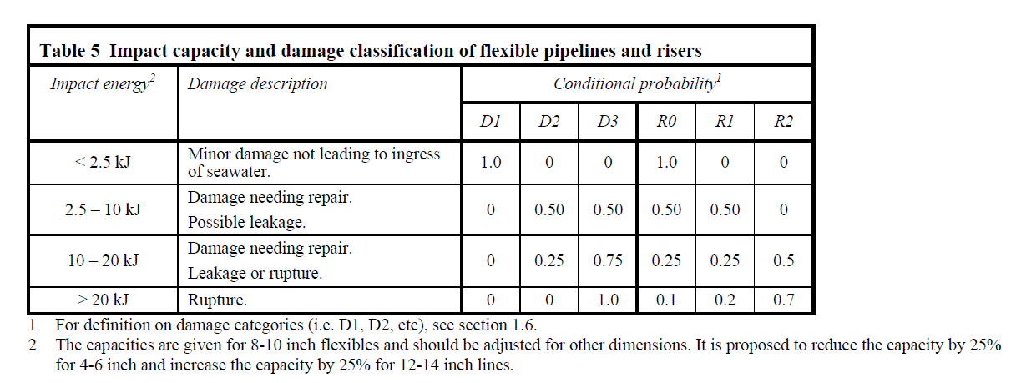

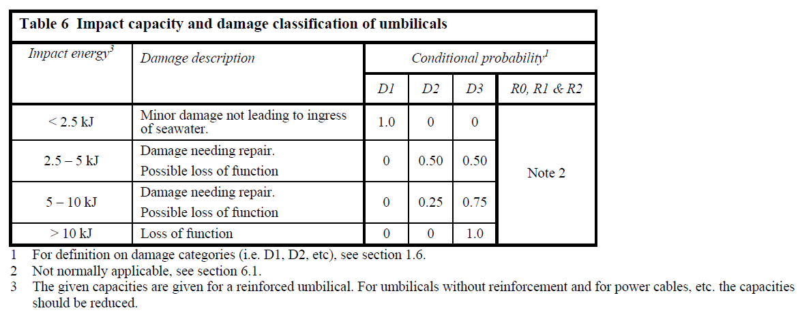

FREQUENCY OF IMPACT / RELEASE CALCULATION:
(check out the Frequency calculation in excel sheet)
TOTAL Failure Frequency:
- Add all individual lifted equipment R1 Release frequency table and present the total R1 Release table (also total R1 Freq)
- Add all individual lifted equipment R2 Release frequency table and present the total R2 Release table (also total R2 Freq)
- Add all individual lifted equipment R2 Release frequency table and present the total R2 Release table (also total R2 Freq)

REPORT:
Input, Figure, calculation assumption, Impact energy and failure freq information (R0,R1 and R2) and some graphs, analysis and presenting of table to be exported to MS word as a report. This format will be decided later.

